**Please note: Not all functionality is covered, only the multiple step processes that may not be intuitive to all users.**

**To start Julia animation**

1. Click and drag across the image of the Mandelbrot set to create a path.

2. Click “Start” on the Julia set animation window.

3. Co-ordinate values can also be typed into the text boxes above the Mandelbrot image, and then plotted by clicking the button. Clicking on the Mandelbrot image will automatically set the coordinates in the text boxes.

NOTE: very short paths (<6 pixels) are not counted. Attempting to run an animation before a path is set will result in a dialogue box telling the user to set a path.

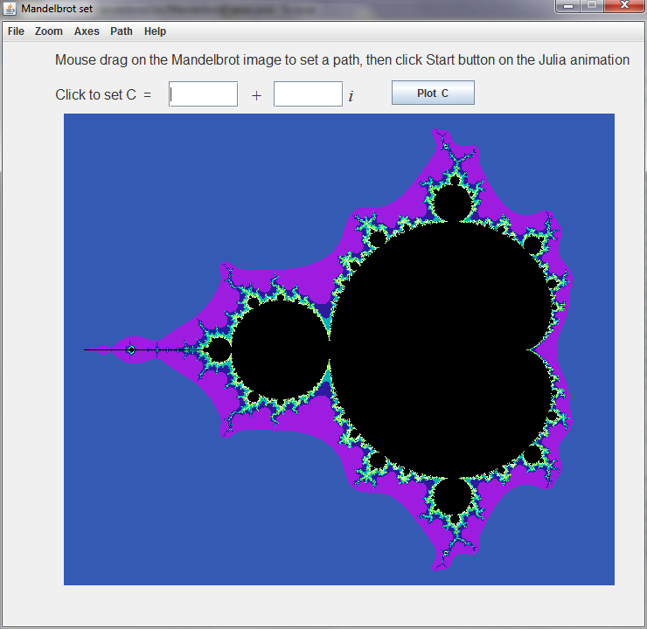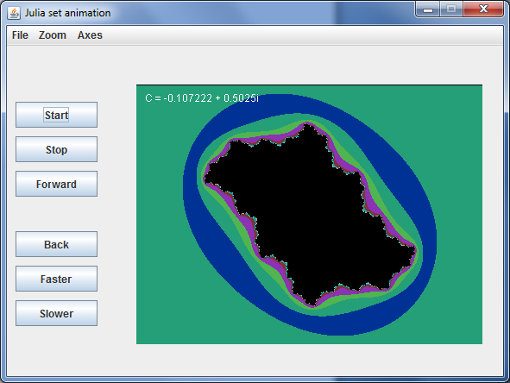

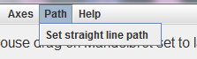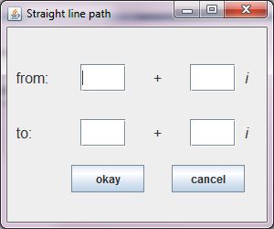

A straight line path can be set by entering two points. Then click “Start” on the Julia set animation window.

**To start Orbit trace animation**

1. Choose whether the value of C is taken from the current animation frame or the last clicked point on the Mandelbrot set and click “Get C”. The value of C can also be typed in.

2. Click “Draw Julia set” This will produce an image of the Julia set corresponding to that value of C.

3. Click on the image in order to set the value of Z. The coordinates chosen should appear in the text fields at the bottom of the frame. The value of Z can also be typed in.

4. Click “Trace Orbit”.

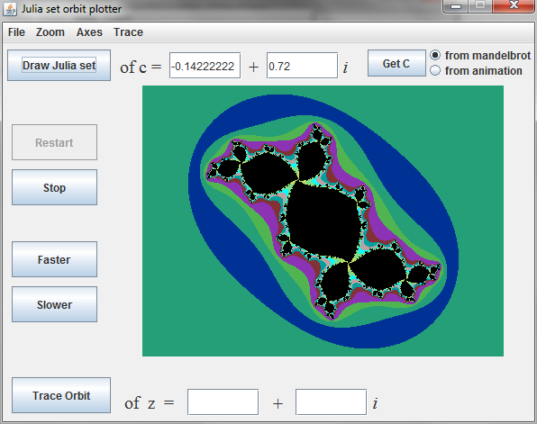

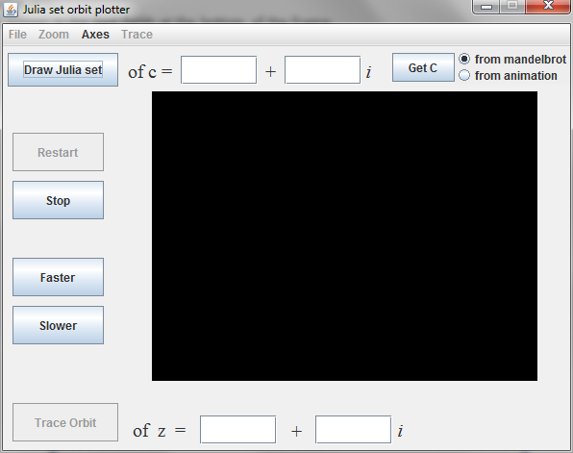

1.

2.

4. Click on the “Trace Orbit” button

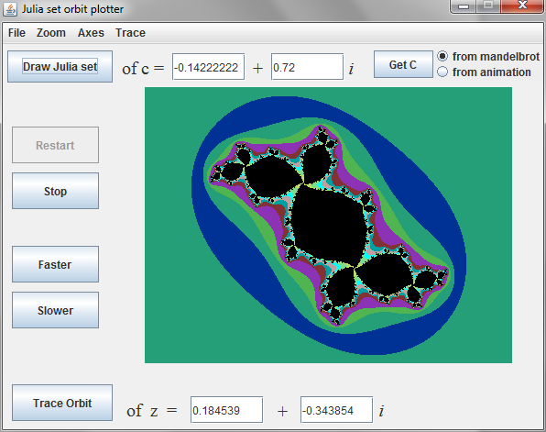

3.

4.

5. To see all points in the orbit, select “Trace” then “Show all points”

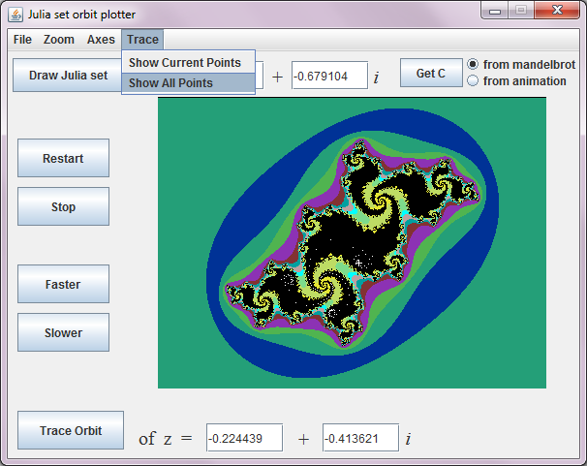

**Zooming**

Zooming is possible on all three windows and works the same way in each. It remains possible when an animation is running.

1. Select “Zoom” from the menu bar.

2. Select “Select area with mouse”. This will allow you to click and drag across the plot area to define a rectangle that will be enlarged.

3. To return to the original image select “Zoom” from the menu bar again and select “Normal”.

NOTE: Zoomed images will be stretched if the user defined rectangle is not a square.

NOTE: Zooming multiple times is possible but requires “Select area with mouse” to be reselected from the menu bar.

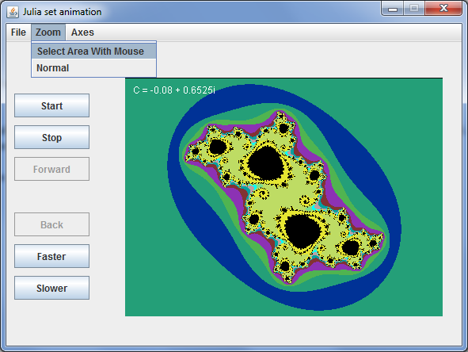

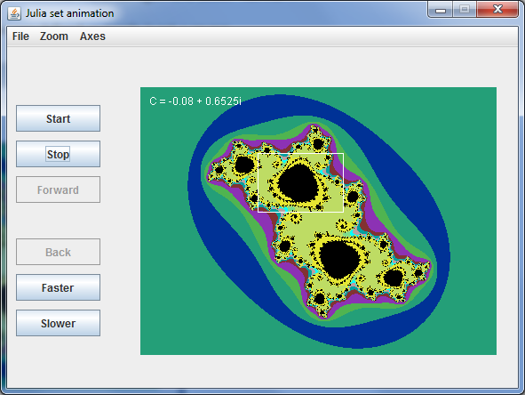

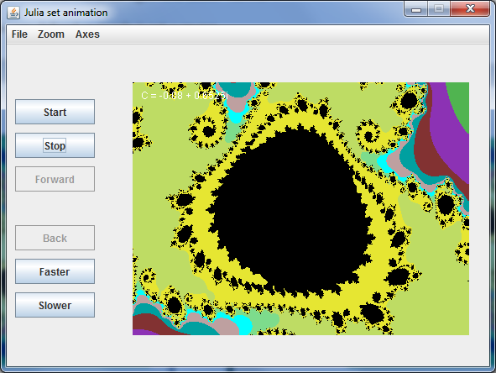

**Saving images and trace data**

All three windows allow the user to save images, and trace data can be saved from the Julia orbit window. When the save button is clicked the software automatically saves in the directory that the program is being run in, with an automatically generated file name. There is no visual feedback for this, so please do not be concerned if there is no indication of saving. The image below shows the points in the orbit of the point - 0.51474262 - 0.0422978 ***i*** in the filled Julia set below.

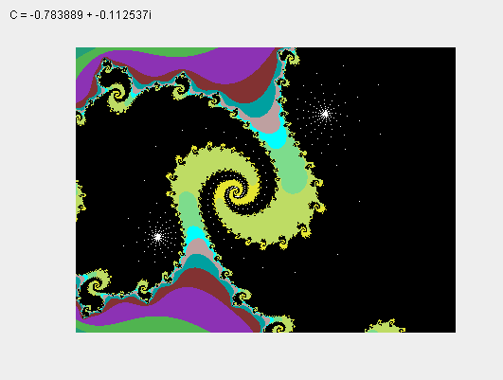

Saved trace data for first 10 points in the orbit

Draw: c = -0.783889 + -0.112537 i Tue Aug 19 21:34:44 BST 2014

Z = -0.514742620064 -0.04229781186999999 i

Z = -0.5207181399786385 -0.06899202699012409 i

Z = -0.517501518485393 -0.04068620006469312 i

Z = -0.5177365452410165 -0.07042665937024162 i

Z = -0.5207977840719489 -0.039612089369570475 i

Z = -0.5142277857299705 -0.07127722326773539 i

Z = -0.5245392269400101 -0.03923154261210339 i

Z = -0.5102867133369018 -0.07138003393316644 i

Z = -0.5285915794361226 -0.039688434172735945 i